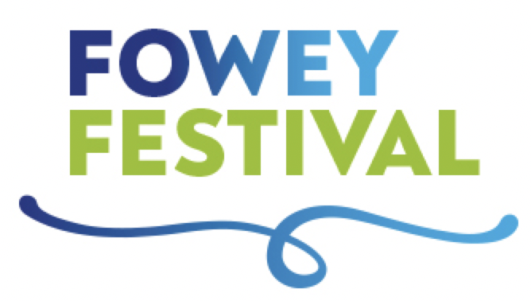

SHORT STORY COMPETITION ENTRY FORM
NAME:
ADDRESS:
DAYTIME TELEPHONE NUMBER:
MOBILE TELEPHONE NUMBER:
EMAIL ADDRESS:
My name and contact details will not appear anywhere on my submission. The story I have entered has not been previously published or broadcast, is all my own work and is not more than 1500 words.
Signed:
Date:
I would like to pay £10 per entry) by:
Cheque payable to The du Maurier Festival Society Electronic transfer
Electronic Transfer:
Bank Account Name: The du Maurier Festival Society
Account No: 61601431
Sort Code: 40-40-04
Reference: (your surname) Fy Fest SSC

Please email chris@foweyfestival.com with the date you made the transfer.
Send your entry/entries and payment to: Fowey Festival of Arts and Literature, Adult Short Story Competition, 6, St Fimbarrus Road, Fowey, Cornwall PL23.

